Validate CVR for Code Combination

Purpose:

This document covers the process of validating the CVR for code combinations and creating the same if Valid and return error in case it’s Invalid.

Requirement : To validate all the code combinations are valid before it gets loaded into ERP Fusion for all the entities.

Process: Process starts by calling the scheduled integration “**INTG24042023_Vadlidatecodecombinations | 2.0.0**” on ad-hoc basis which accepts the comma separated parameter value for the XFM tables (e.g. XXMX_GL_OPENING_BALANCES_XFM,XXMX_GL_SUMMARY_BALANCES_XFM )for which validation needs to be performed.

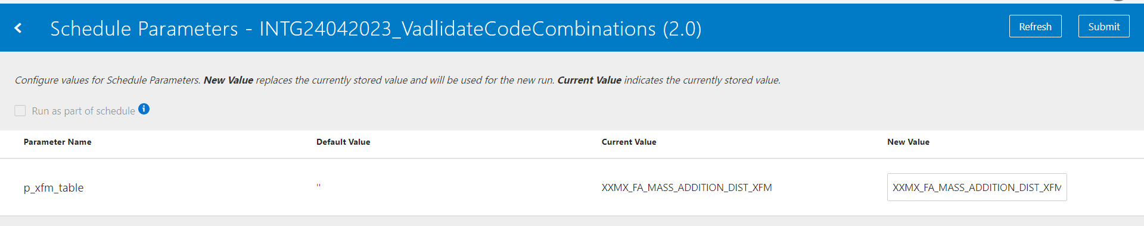

Integration triggers the procedure ‘xxmx_validate_code_comb_cvr_pkg.gl_code_comb_cvr’ which inserts the data into ‘xxmx_gl_account_code_combinations’. This procedure extracts the incremental data for each entity or table.

Then a loop runs in a batch of 800 records with a status in (‘Invalid’, ‘NEW’) and calls the integration **“INTG_CHILD_CODE_COMBINATIONS |1.0.0” (**asynchronously, so that multiple calls can be done parallellyand save the time) which validates and create each code combination and update the status into the table ‘xxmx_gl_account_code_combinations’.

At the end you can check the status in the table ‘xxmx_gl_account_code_combinations’.

Our COA is combination of 7 segments. This code can be modified as per COA configuration.

Please find the below link for the API. There are some privileges to be assigned to the user then only we can see this service in OIC.

[Account Combination Validation Service (oracle.com)](https://docs.oracle.com/en/cloud/saas/financials/22d/oeswf/accountcombinationvalidationservice-d16624e374.html)

Below is the list of tables where validation is being performed.

1. **XXMX_GL_OPENING_BALANCES_XFM**
2. **XXMX_GL_SUMMARY_BALANCES_XFM**
3. **XXMX_FA_MASS_ADDITIONS_XFM**
4. **XXMX_FA_MASS_ADDITION_DIST_XFM**
5. **XXMX_SCM_PO_DISTRIBUTIONS_STD_XFM**
6. **XXMX_AP_SUPP_SITE_ASSIGNS_XFM - LIAB, PREPAY & BILL PAYABLE**
7. **XXMX_GL_HISTORICALRATES_XFM**
8. **XXMX_PER_ASSIGNMENTS_M_XFM**
9. **XXMX_PPM_PRJ_LBRCOST_XFM**
10. **XXMX_PPM_PRJ_MISCCOST_XFM**

Below are a few objects which are used as a pre-requisite.

Table: **xxmx_dm_asset_books_in_scope**

**Data Model**: /shared/Custom/Maximise Data Migration/Reference Data Reports/XXMX_FA_BOOK_LEDGER_DM

**Query**: select fbc.book_type_code, gl.ledger_id, gl.name from fa_book_controls fbc, gl_ledgers gl where fbc.set_of_books_id=gl.ledger_id

**Report:** /Custom/Maximise Data Migration/Reference Data Reports/XXMX FA BOOK LEDGER REPORT.xdo

Integration: **INTDM99999_ERP_SAAS_FA_BOOK_LEDGER**, inserts the data into the above table which is used for fixed asset code combination validations.

Table: **xxmx_dm_fusion_das**

**Data Model:** /Custom/Maximise Data Migration/Reference Data Reports/XXMXGLLedgerAccessSetDM

**Query:** select   
gasl.ACCESS_SET_ID, gas.NAME DAS_NAME, gl.name LEDGER_NAME, gasl.LEDGER_ID, gasl.ACCESS_PRIVILEGE_CODE, null BU_NAME, null BU_ID, null CURRENCY_CODE   
  
from gl_access_sets gas,gl_access_set_ledgers gasl,  
gl_ledgers gl  
where enabled_flag='Y'  
and gas.access_set_id= gasl.access_set_id  
and gasl.ledger_id=gl.ledger_id  
and gas.name in ( 'ALL Ledgers', 'India INR Secondary Ledger')  
order by gl.name

**Report:** /Custom/Maximise Data Migration/Reference Data Reports/XXMXGL Ledger Access Set Report.xdo

Integration**: INTDM99999_ERP_SAAS_GL_ACCESS_SET**, inserts the data into the above table which stores ledger, BU and access set details.